# Source Control Screenshot

Link: <https://github.com/profiteroles/RAD>

Screenshot:

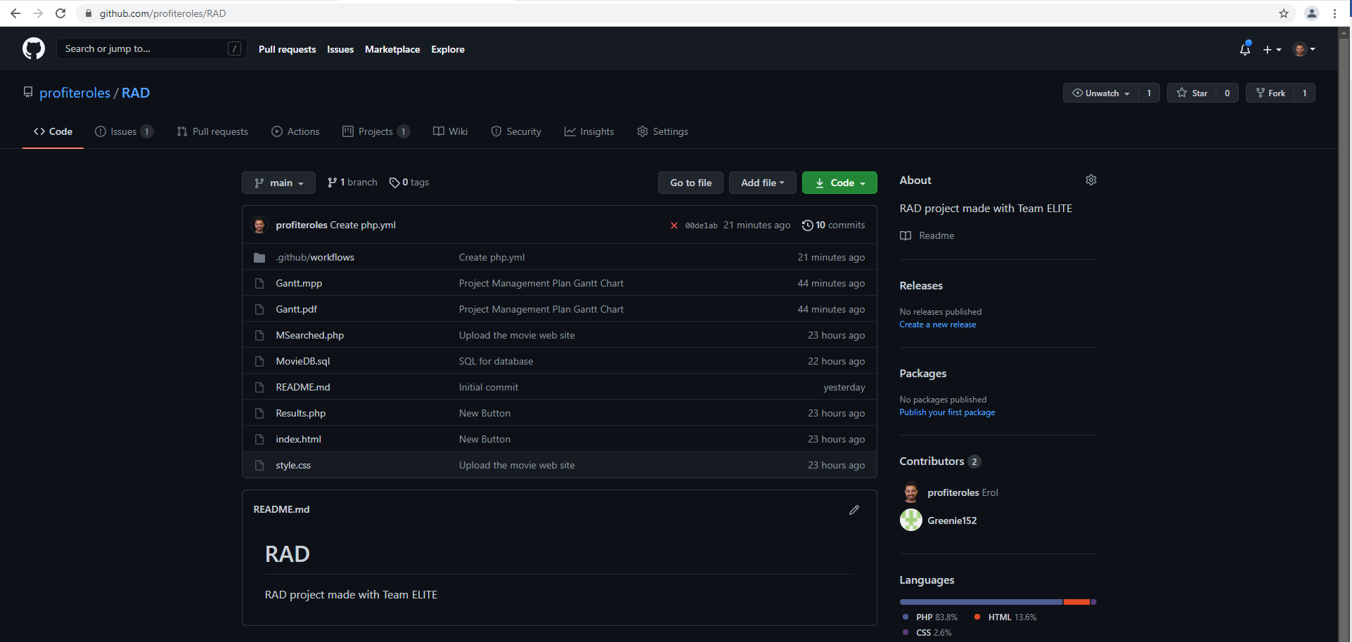

Figure 1- GitHub Screenshot

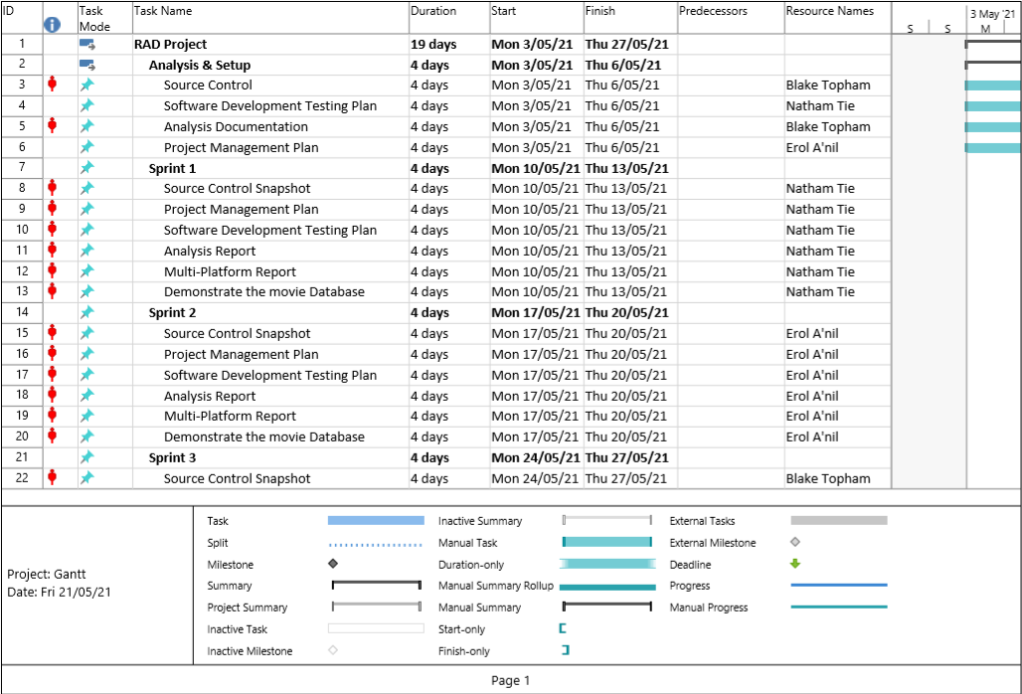

Figure 2- GANTT Chart

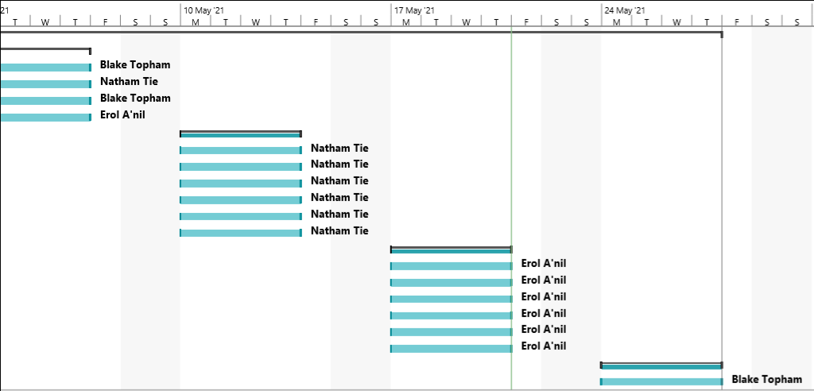

Figure 3- GANTT Chart (continued)

Overall the only data being tested for consistency validation is the database itself. The current measures we have in place in case of failure are that we have the original SQL file used to create the database stored in multiple locations such as personal data storage and a GitHub repository.

As such if the file on the server is corrupted or damaged in any way the database can be easily restored. This will lose any updates made since the last time this backup was renewed but will restore the database to working order.

A table showing how the data will be in a multitude of events is included below:

|  |  |  |  |  |
| --- | --- | --- | --- | --- |
| **Event no** | **description** | **Main file status** | **Backup status** | **Explanation** |
| 1 | Main file is corrupted or deleted | Main file recoverable from backup | Unchanged | Problem can be resolved easily however site will not operate in the meantime |
| 2 | One backup lost | unchanged | Backup can be restored either from second backup instance or generated again from main file | This will have absolutely no effect other than the need to re-generate a backup |
| 3 | All backups lost | unchanged | All backups gone but can be re-generated from main file fairly painlessly and restored | This will be a dangerous situation however it will be easy to resolve as it will simply need the generation of a new backup and it being placed in all the places it needs to be |
| 4 | Main file and all backups lost | Lost | Lost | This would be a catastrophic situation however the chance of it happening are insanely small as it would require the simultaneous deletion or corruption of multiple files stored entirely separately from one another |